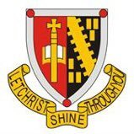

ST MUNGOS PARENT COUNCIL
CHAIRPERSON: STEVE FELTBOWER
Meeting to be held on Thursday 7th of September at 7pm
AGENDA

- Welcome & Apologies

- Approval of Previous Minutes

- Updates on Action Points from Last Meeting

- Rectors Report

- Treasurers Report

- Future of AGM meetings (AC)

- AOB

