Our Cluster Primary Schools

We have six main associated primary schools, although pupils from St. Patrick’s, Denny attend St. Modan’s High School.

To view St. Mungo’s Catchment area map, click here

St. Francis Xavier’s    St. Francis Xavier’s Primary School  Merchiston Avenue  FALKIRK  FK2 7JS  Head Teacher: Mr M Murray  Tel: 01324 508577  Website:  https://www.st-francis.falkirk.sch.uk/  Email: stfrancisprimaryschool@falkirk.gov.uk | St Andrew’s  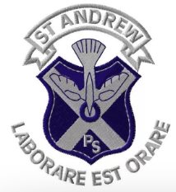  St Andrew’s RC Primary School  Hawley Road  FALKIRK  FK1 1SH  Head Teacher: Mrs K. Devlin  Tel: 01324 508650  Website:  https://www.st-andrews.falkirk.sch.uk/  Email:  standrewsprimaryschool@falkirk.gov.uk | St Bernadette’s  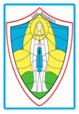  St Bernadette’s Primary School  Edward Avenue  Stenhousemuir  FK5 4XR  Head Teacher: Mrs M. Savage  Tel: 01324 503400  Website:  http://stbernadettes.edusite.co.uk/parents/  Email:  stbernadettesprimaryschool@falkirk.gov.uk | Sacred Heart  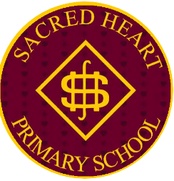  Sacred Heart Primary School  Bowhouse Road,  Grangemouth  FK3 0EU  Head Teacher: Mr T. McGovern  Tel: 01324 508730  Website:  https://www.sacredheart.falkirk.sch.uk/  Email: sacredheartprimaryschool@falkirk.gov.uk | St Joseph’s  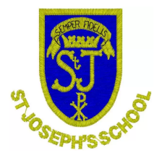  St Joseph's Primary School  Broomhill Road  Bonnybridge  FK4 2AN  Head Teacher: Mrs A Brady  Tel: 01324 503150  Website:  https://www.st-josephs.falkirk.sch.uk/  Email:  stjosephsprimaryschool@falkirk.gov.uk

See below for St Mary’s, Bo’ness

St. Mary’s
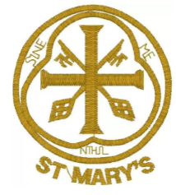

St. Mary’s Primary School
Gauze Road
Bo’ness
FALKIRK
EH51 9QB

Head Teacher: Mr S McPeake

Tel: 01506 778380

Website:
https://www.st-marys.falkirk.sch.uk/

Email:
stmarysprimaryschool@falkirk.gov.uk

