{"A?":"B","a":5,"b":1587246157038,"c":"DAD5yjktza4","d":"B","A":[{"A?":"I","A":15.632340159991728,"B":644.5285268947749,"D":89.48457305327776,"C":89.48457305327776,"a":{"B":{"A":{"A":"MAD51aQDgYk","B":1},"B":{"D":89.48457305327776,"C":89.48457305327776}}}}],"B":1122.51968503937,"C":793.7007874015748}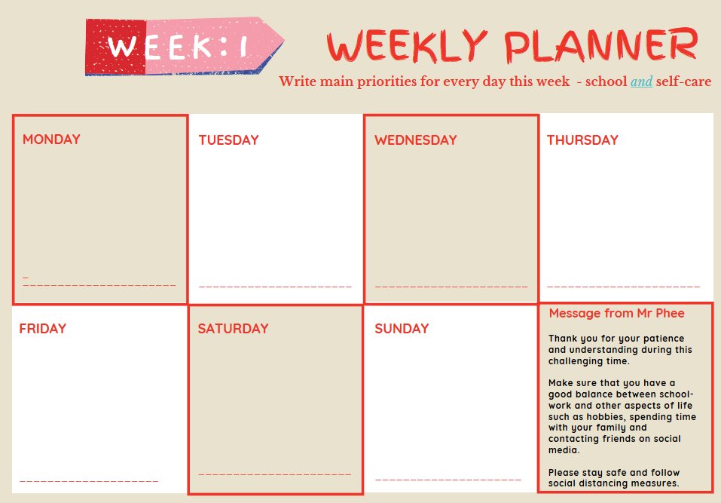

**Use this template to plan your daily and/or weekly activities and work. Type straight onto the document.**

**Don’t print this sheet, instead save a master copy on your computer. Then you can save individual files by date, meaning you can keep track of your work.**

**KEY MESSAGE**

**Thank you for your patience and understanding during this challenging time. Make sure you have a good balance between school-work and other aspects of your life such as hobbies, spending time with your family and contacting friends on social media.**

**Please stay safe and follow social distancing measures**

**MONDAY**

**WEDNESDAY**

**SUNDAY**

**FRIDAY**

**THURSDAY**

**TUESDAY**

**SATURDAY**