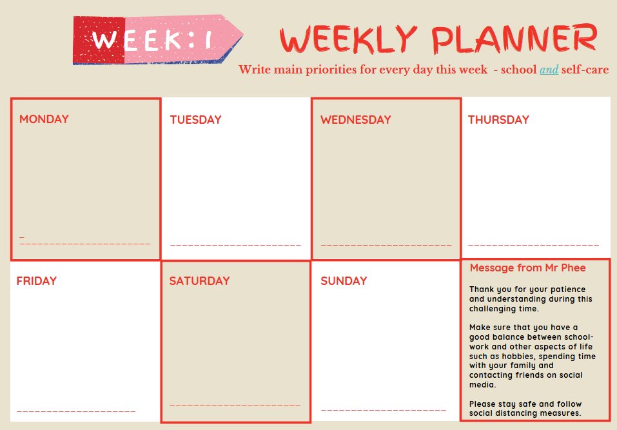
{"A?":"B","a":5,"b":1587246157038,"c":"DAD5yjktza4","d":"B","A":[{"A?":"I","A":15.632340159991728,"B":644.5285268947749,"D":89.48457305327776,"C":89.48457305327776,"a":{"B":{"A":{"A":"MAD51aQDgYk","B":1},"B":{"D":89.48457305327776,"C":89.48457305327776}}}}],"B":1122.51968503937,"C":793.7007874015748}
MESSAGE FROM MR PHEE
Thank you for your patience and understanding during this challenging time. Make sure you have a good balance between school-work and other aspects of your life such as hobbies, spending time with your family and contacting friends on social media.

Please stay safe and follow social distancing measures

Use this template to plan your daily and/or weekly activities and work. Type straight onto the document.
Don’t print this sheet, instead save a master copy on your computer. Then you can save individual files by date, meaning you can keep track of your work.

MONDAY

WEDNESDAY

SUNDAY

FRIDAY

THURSDAY

TUESDAY

SATURDAY

